Written Assignment

Your organization has recently become aware of potential ICMP related attacks on its network and has tasked you with investigating this issue. As part of your investigation, you are to analyze ICMP traffic patterns in the network to gain a better understanding of the situation. One aspect of this investigation will involve looking at ICMP messages generated by Ping programs. In particular, you will be tasked with answering the following questions:
1. Choose the first ICMP request packet that you come across and answer the following questions:
a. What is the packet protocol and protocol number?
Protocol: ICMP
Protocol number: 1
b. What are the type and code number values of the ICMP packet?
Type: 8(Echo (ping) request)
Code number values: 0
c. What is the checksum number and status?
Checksum number: 0x86fe
Checksum status: Good
2. Examine the corresponding ICMP reply packet and answer the following questions:
d. What type and code number values do the ICMP packets have?
Type: 0(Echo (ping) reply)
Code number values: 0
e. How many bytes are the checksum and identifier fields?
Checksum bytes: 2 bytes
Identifier fields bytes: 2 bytes
3. Another aspect of this investigation will involve looking at ICMP messages generated by Traceroute programs. In particular, you will be tasked with answering the following questions:
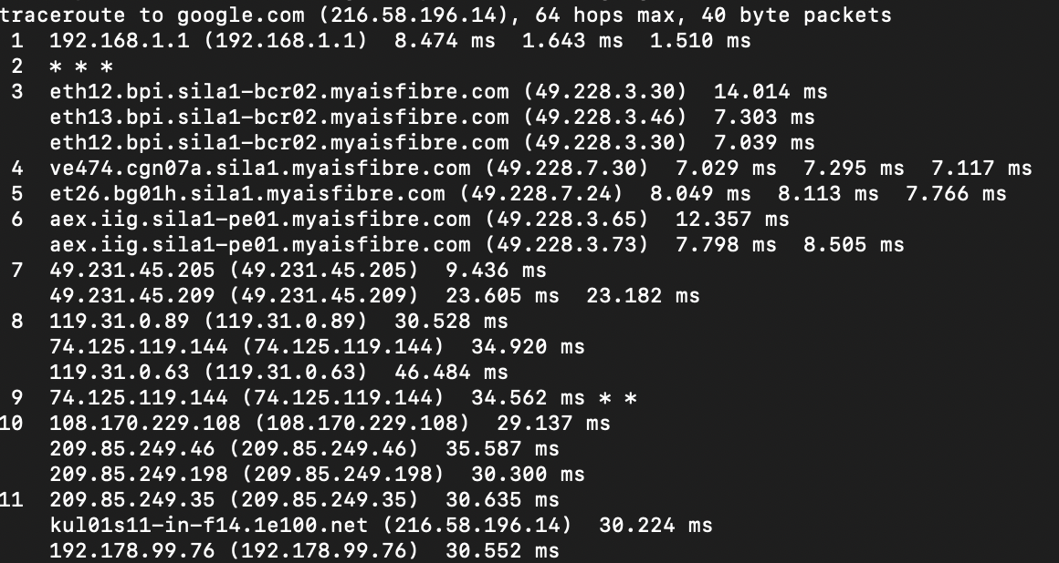
f. What is the IP address of your host PC (from the traceroute result)?
Host IP address: 192.168.1.1
g. What is the IP address of the target destination host (from the traceroute result)?
Destination IP address: 192.168.1.107

